Friska target audience profile guide

## Project Scenario

The customer database for the deodorant brand “Friska” has been segmented and analyzed with the Five Human Factors method (emotional, cognitive, social, cultural, and physical factors) by a Sr. Analyst at Friska. You will take on the role of the Digital Marketing Analyst to create a target audience profile from the segmented data. Fill out the tables in the guide below to complete your persona.

## Step 1: Name and Gender

Based on the data below, choose a gender for your persona and write it in the table. Then, pick a name for your persona and enter it in the table. You may want to use a random name generator like [this one](https://www.fakenamegenerator.com/gen-female-ch-us.php) to help you pick a name.

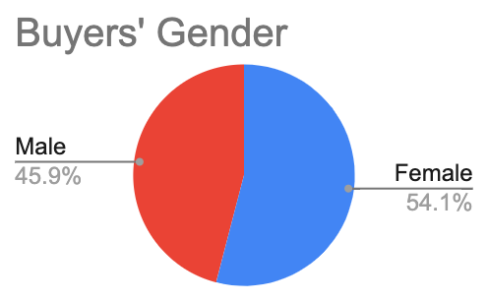

| ***Name*** |  |
| --- | --- |
| ***Gender*** |  |

## Step 2: Age

Based on the data below, pick an age for your persona and enter it in the table.

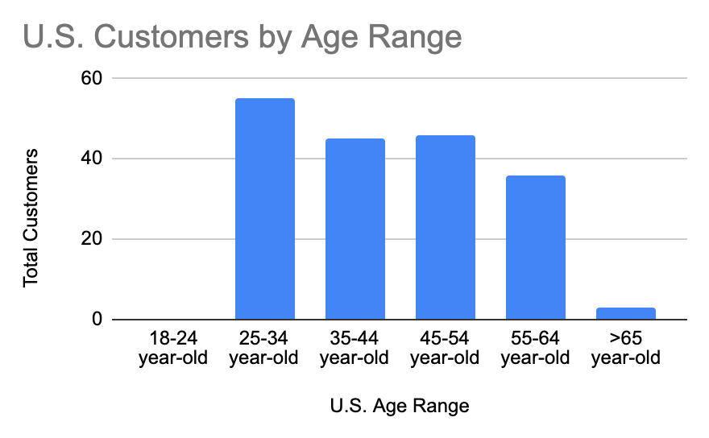

| ***Age*** |  |
| --- | --- |

## Step 3: Employment and economic position

Based on the information below, choose an income level for your persona. A tool like [ZipRecruiter](https://www.ziprecruiter.com/Salaries/Entry-Level-Product-Manager-Salary--in-California) might be useful to find salary information. If you wish, you can do some additional research on your own to fill out more information about your persona’s employment.

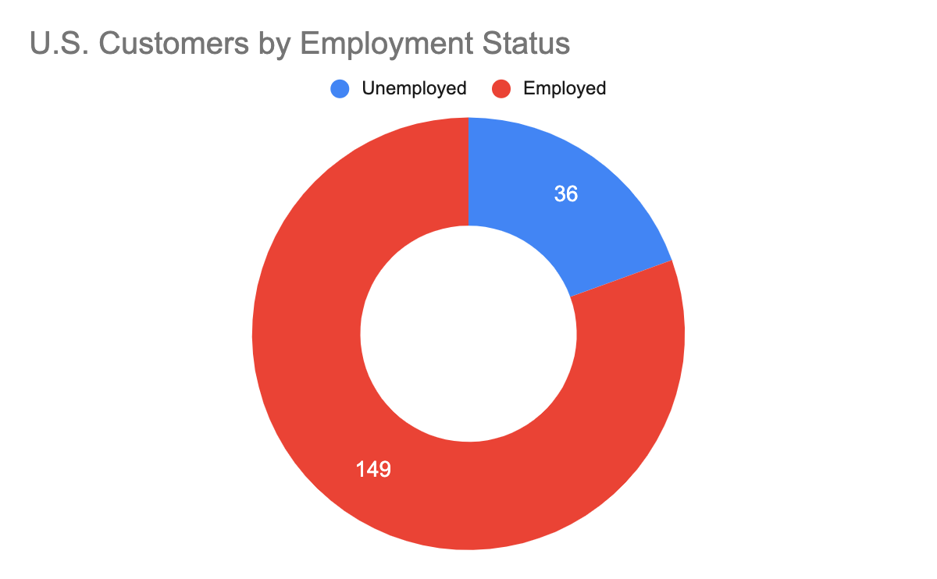

| ***Income level*** |  |
| --- | --- |
| ***Employment*** | *optional* |

*Note: You can reference the exemplar at the bottom of this document for inspiration on filling out the employment section.*

## Step 4: Location, Personal Background, and Family Situation

Based on the data below, pick a location for your persona and enter in the table. Then, based on the choices you have made for your persona so far and the guiding questions in the table, fill out some personal and family background information for your persona.

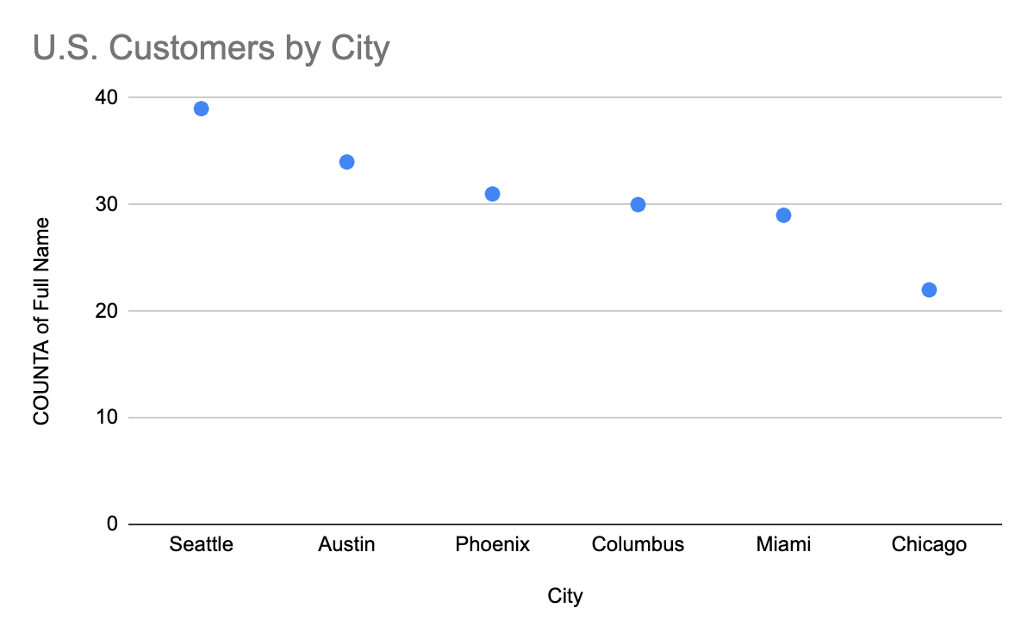

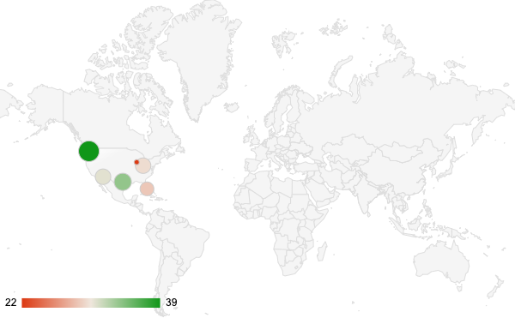

| ***Location*** |  |
| --- | --- |
| ***Personal background*** | *Lifestyle:*  *What do they value in the products they buy?*  *What is their highest level of education, and where did they study?*  *What activities do they regularly engage in?* |
| ***Family background*** | *What values did they learn as a child about purchasing?*  *Are there any shared beliefs or ideologies within the family that might influence their choices and preferences?*  *What are some important family traditions or holiday celebrations they participate in?*  *How do these traditions influence their purchasing decisions and behaviors?* |

*Note: You can reference the exemplar at the bottom of this document for inspiration on filling out the personal and family background sections.*

## Step 5: Attitudes and desires

Based on the data below, write some information about the attitudes and desires of your persona.

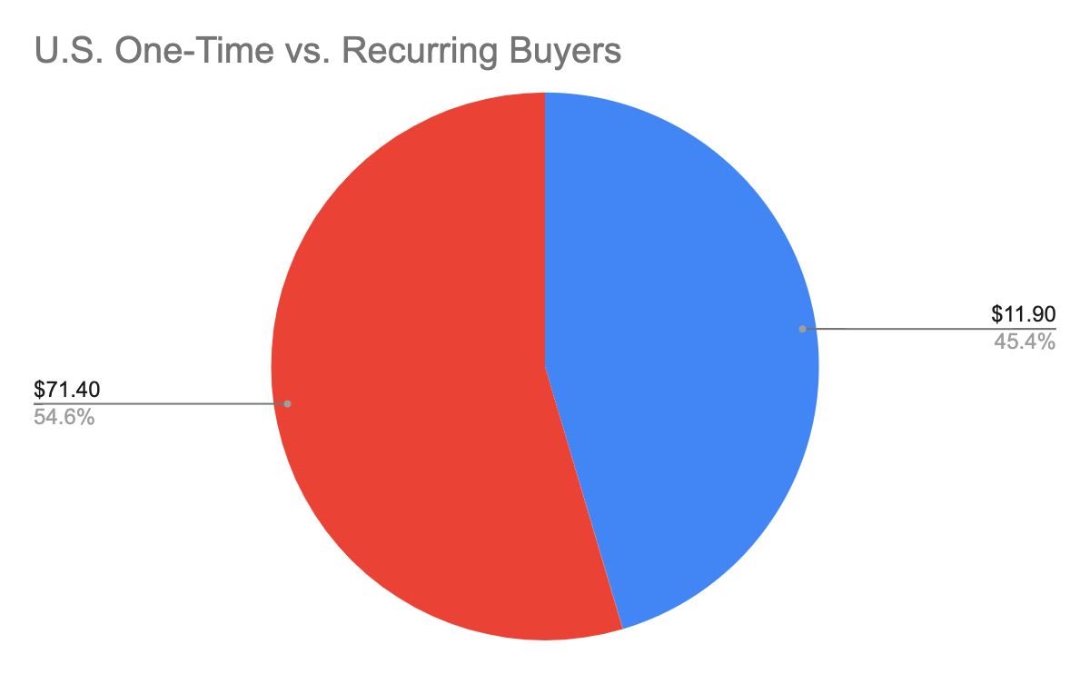

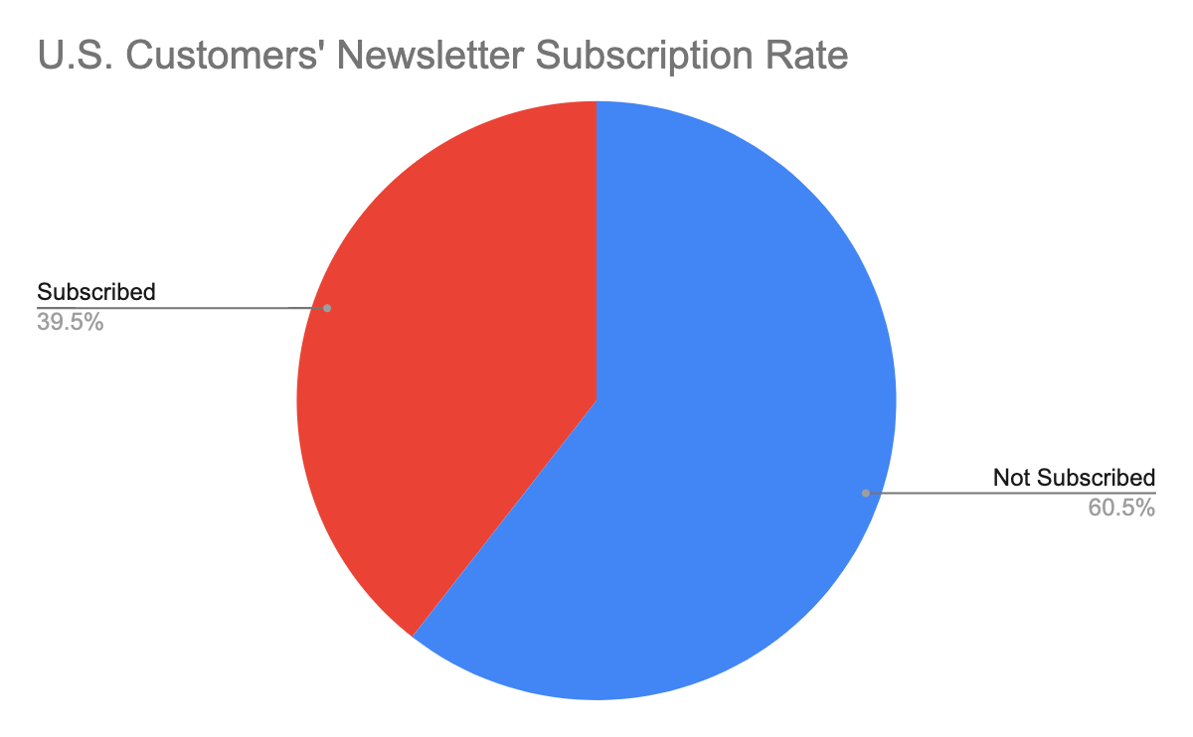

| ***Attitudes and Desires*** |  |
| --- | --- |

*Note: You can reference the exemplar at the bottom of this document for inspiration on filling out the attitudes and desires section.*

## Optional - Make it visual!

Enter your information in the [HubSpot Make My Persona tool](https://www.hubspot.com/make-my-persona) to create a visual version of your target profile. Click “Build My Persona” then “Skip walkthrough mode” to customize the sections in the tool to match what you filled out in this worksheet.

The marketing persona that you create should fit on one page, like the example below.

## Screenshot of example target audience profile for Jenny Appleby.

When you’re ready, go back to [the assignment](https://www.coursera.org/learn/customer-understanding-and-digital-marketing-channels/assignment-submission/YcUNH/creating-a-target-audience-profile) to complete the questions.